View this email in your browser

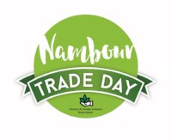
On Wednesday 29 August at Nambour Trade Day you'll find exceptional quality & service from various horticulture traders.
- Great range of growers & allied traders on display
- Meet with new local buyers registered to attend
NAMBOUR SHOWGROUNDS
Main entry on Coronation Avenue, Nambour QLD


FREE CAR PARKING
BREAKFAST AVAILABLE
Standholder entry from 6.00am
Buyer entry from 7.00am
Buying commences 7.30am
Trolleys available & stock pick up from 8.00am
For further information contact NGIQ - 07 3277 7900

NAMBOUR - Download Buyer Registration Form

NAMBOUR - Download Standholder Registration Form

